



**Course title:** Numerical Methods.

* **Lab report on:** A c program to implements forward difference table.

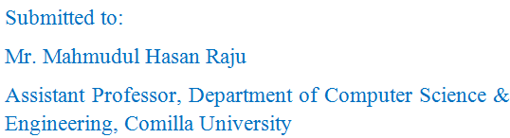

Date of Submission: 30-03-2016

Submitted by:

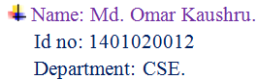

* A c program to implements forward difference table.

#include <iostream>

**using** **namespace** std**;**

**int** main**()**

**{**

**int** i**,**j**,**n**,**k**,**l**,**a**[**10**]** **[**10**],**x**;**

cin**>>**n**;**

**for** **(**i**=**1**;** i**<=**n**;** i**++)**

**{**

**for(**j**=**i**;** j**<=**n**;** j**++)**

**{**

a**[**i**][**j**]=**j**-**i**;**

**}**

**}**

cout**<<"\n\n";**

**for** **(**i**=**0**;** i**<**n**;** i**++)**

**{**

cout**<<"del^"<<**i**<<" ";**

**}**

cout**<<"\n\n";**

**for** **(**i**=**1**;** i**<=**n**;** i**++)**

**{**

x**=**i**;**

**for(**j**=**1**;** j**<=**n **&&** x**<=**n**;** j**++)**

**{**

cout**<<"del^"<<**j**-**1**<<"y"<<**a**[**j**][**x**]<<" ";**

x**++;**

**}**

cout**<<**endl**;**

**}**

**return** 0**;**

**}**

Sample input/output:

